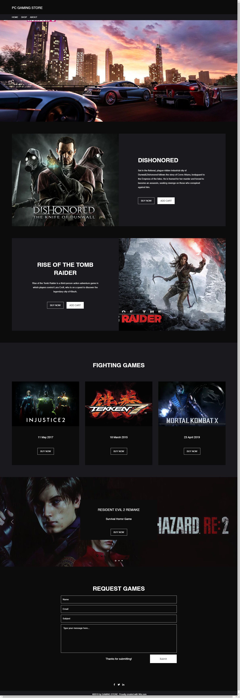

Information:

The Name of My website is PC GAMING STORE, this also buying game only pc game not console.

My target customer is PC gamers or who like to buy a PC game. In online.

This website will help the customer to easily to buy a games in lowest price through online. No hassle to buy just sign up or if you have existing account just log in and click buy.

Why black color My website because gamers like black color and much attractive in their eyes. There are many genre of the games such a fighting games, survival games and etc.

I have request game if you want to request what I will add in My game list.